**NAME : DIVYANSHU SHARMA**

**PES1UG20CS806**

**CN LAB ( WEEK 8)**

1. **IPv4 ADDRESSING AND TOPOLOGY CREATION**

* The following topology is created and deployed on ClayNet.

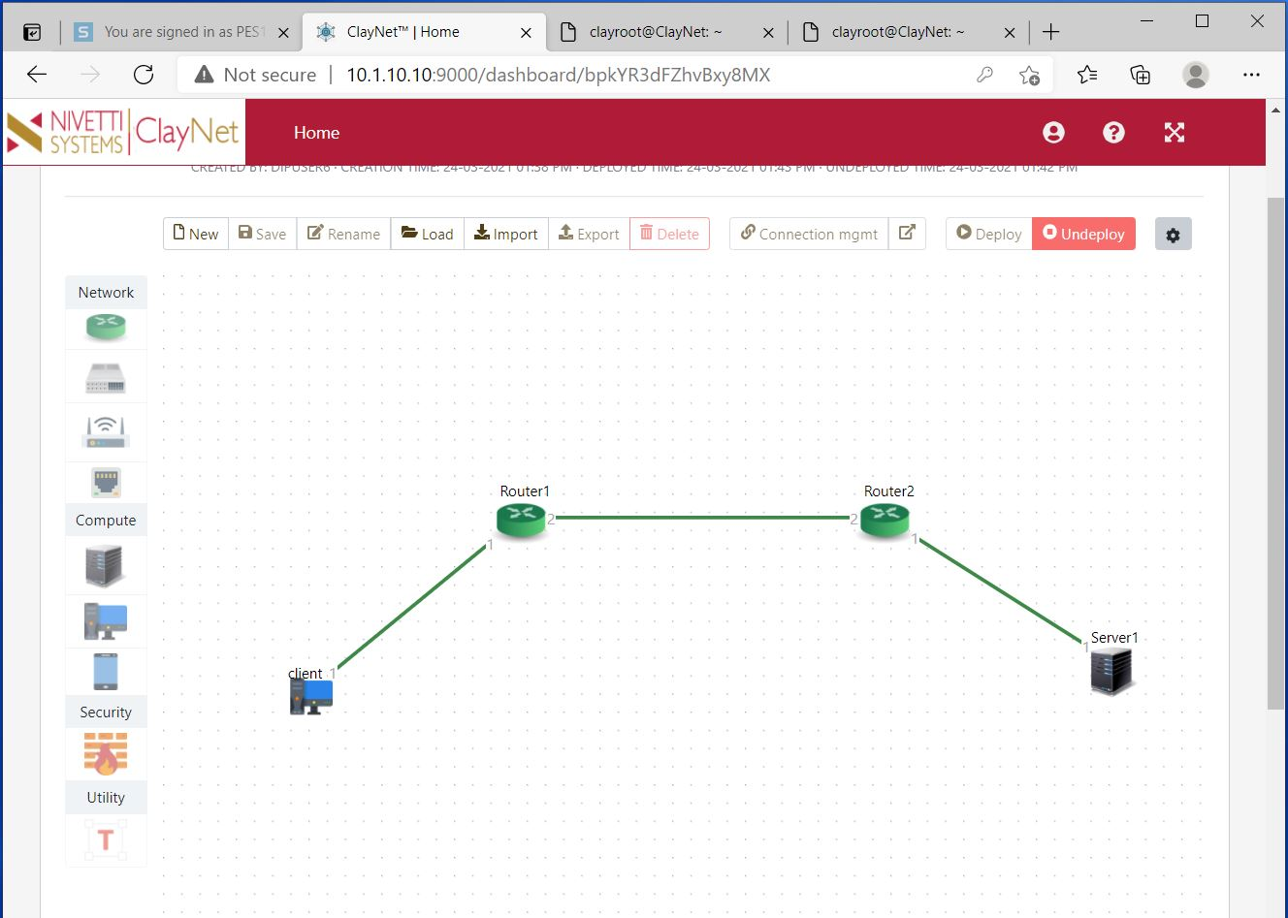

* Configuration of End-System devices is given below:

|  |  |  |
| --- | --- | --- |
| **END SYSTEM** | **IP ADDRESS** | **GATEWAY** |
| Client 1 | 10.10.10.2/24 | 10.10.10.1 |
| Server 1 | 30.30.30.2/24 | 30.30.30.1 |

* In the same way the Router are configured:

|  |  |  |
| --- | --- | --- |
| **ROUTER** | **INTERFACE NUMBER (port)** | **IP ADDRESS** |
| Router 1 | 1 | 10.10.10.1/24 |
| Router 1 | 2 | 20.20.20.1/24 |
| Router 2 | 1 | 30.30.30.1/24 |
| Router 2 | 2 | 20.20.20.2/24 |

1. **PING COMMAND**

* From client 1, a ping command is made to Server1
* However, this ping command fails because the routing table entries have not been configured yet for Router1 and Router2.
* We obtain a Destination Host Unreachable status

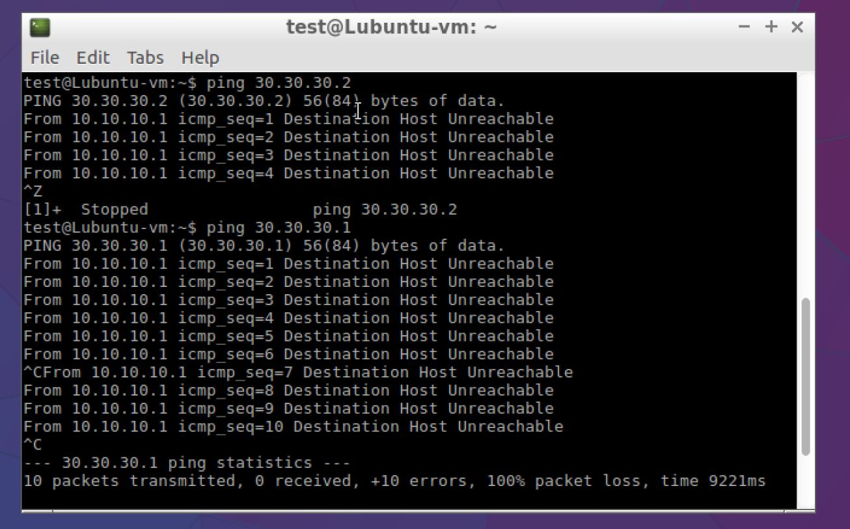

1. **Configuration of Routing Table Entries**
   1. **Router 1**

* The Routing Table entries for Router 1 are configured using the below commands in the console window

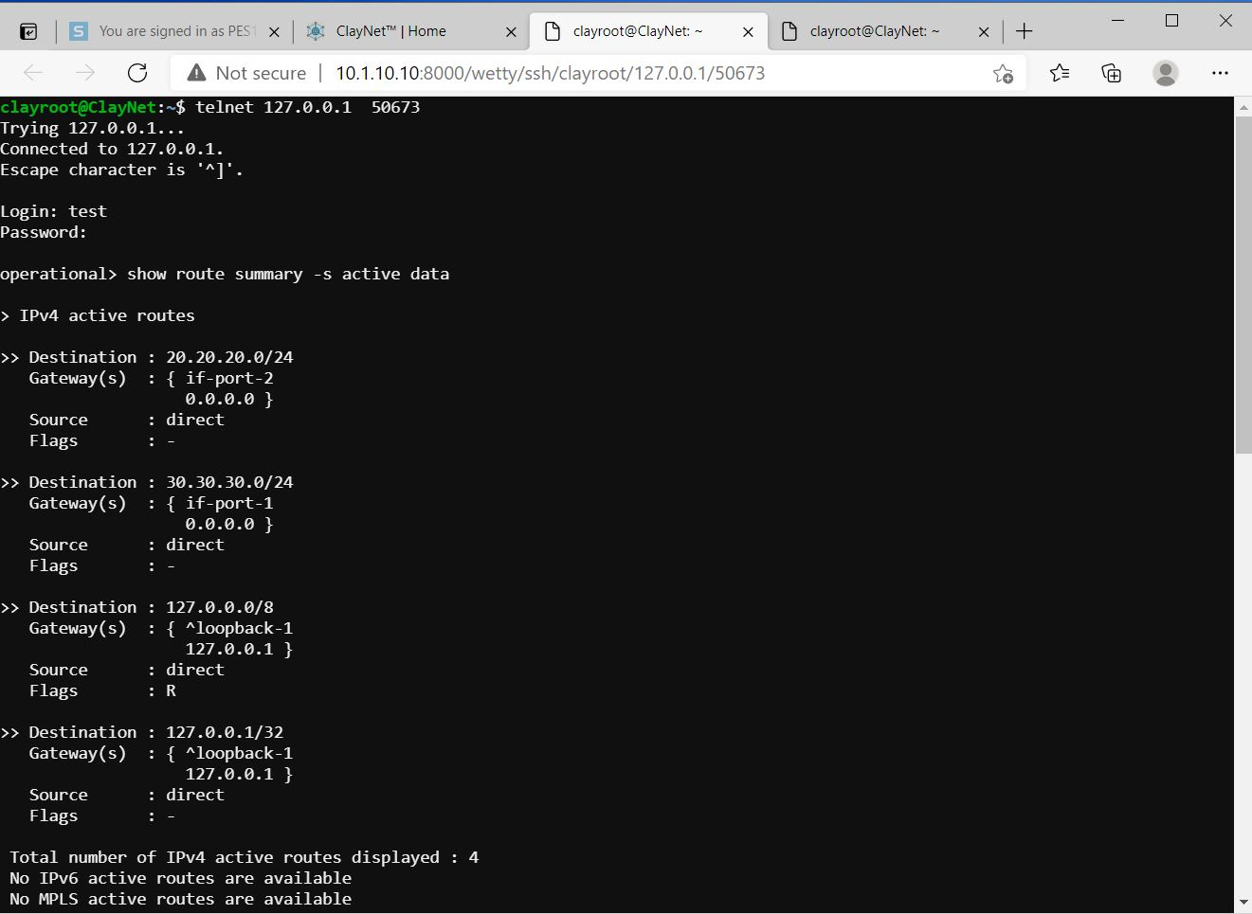

* The resulting Routing Table Entry is shown below

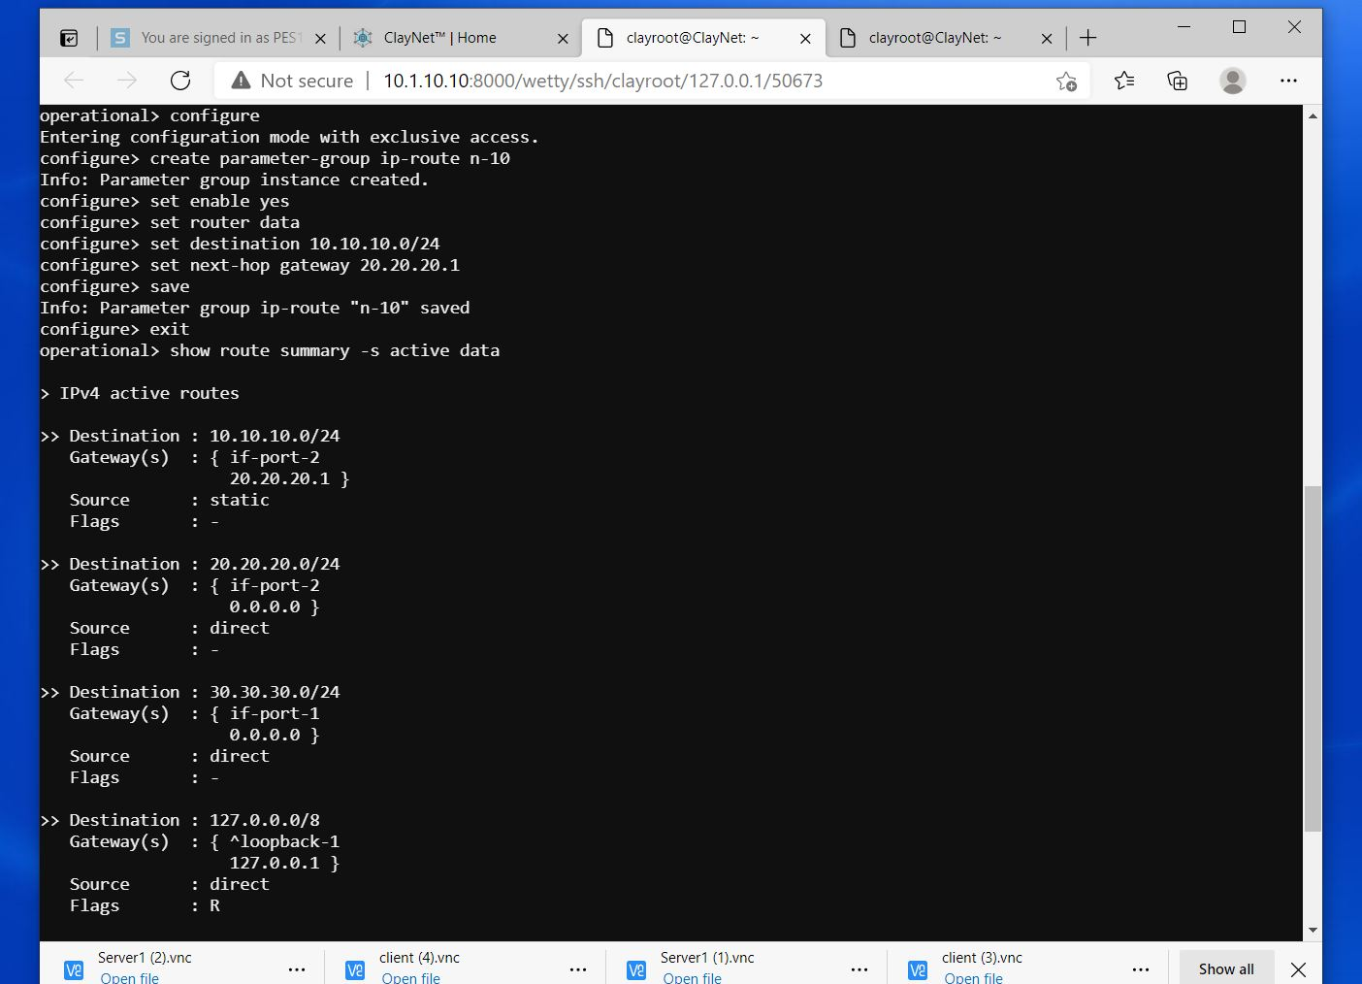

* 1. **Router 2**
* The Routing Table entries for Router 2 are configured using the below commands in the console window.

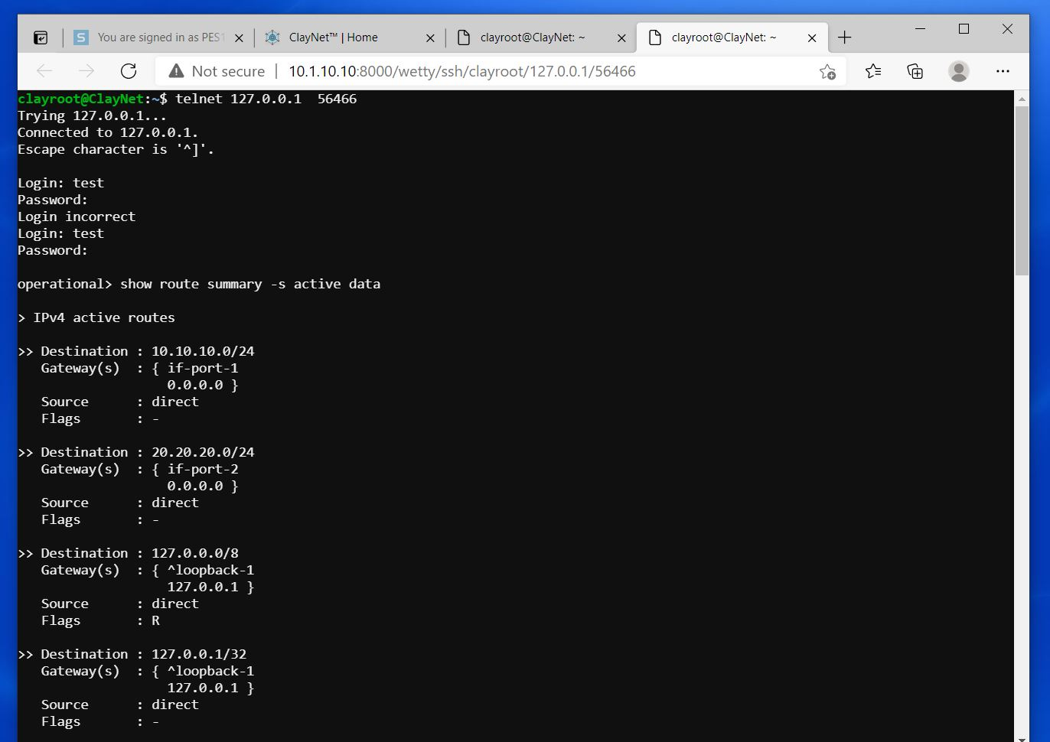

* The resulting Routing Table Entry is shown below.

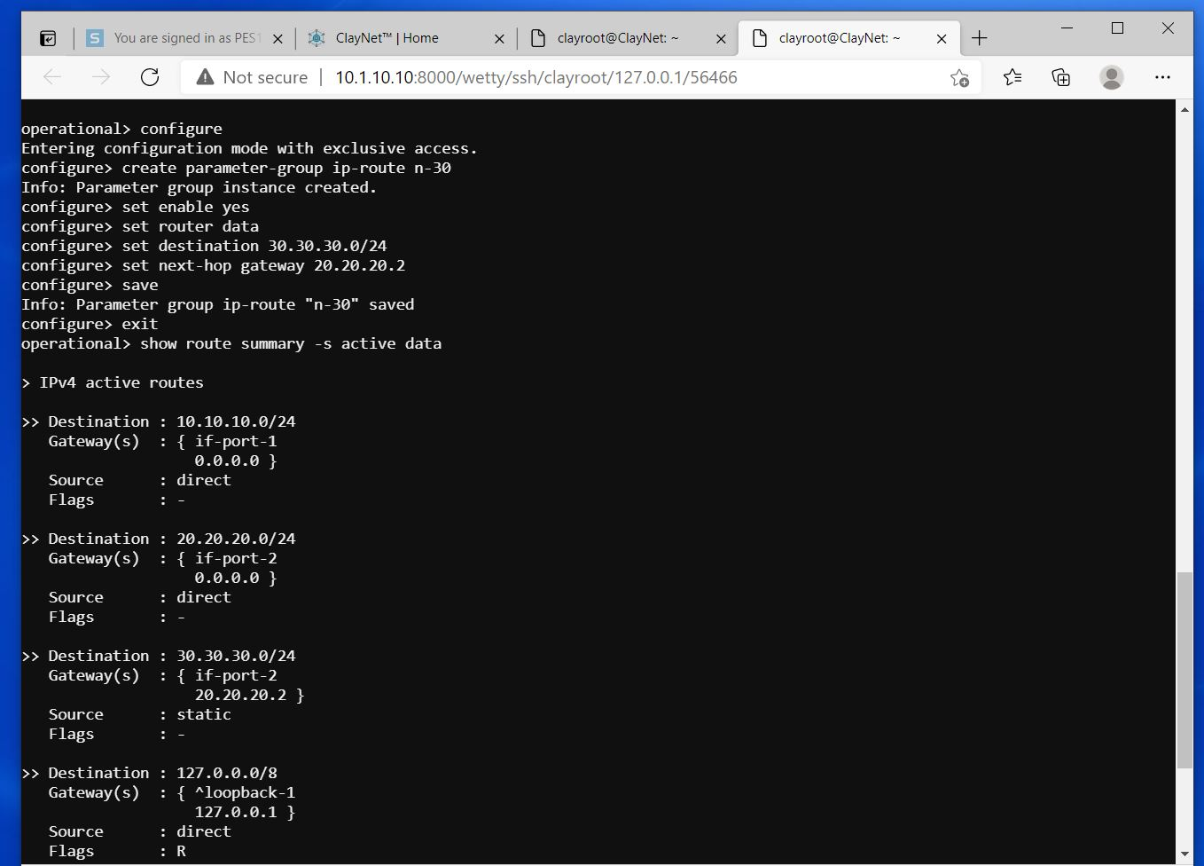

1. **Observation**

* The resulting Routing Table Entry is shown below.
* To verify this, the ping command is again used to ICMP request packets to the other.
* Since there are 2 hops between the systems, the TTL value is decremented by 2. Hence the value is decremented from its default value of 64 to 62.

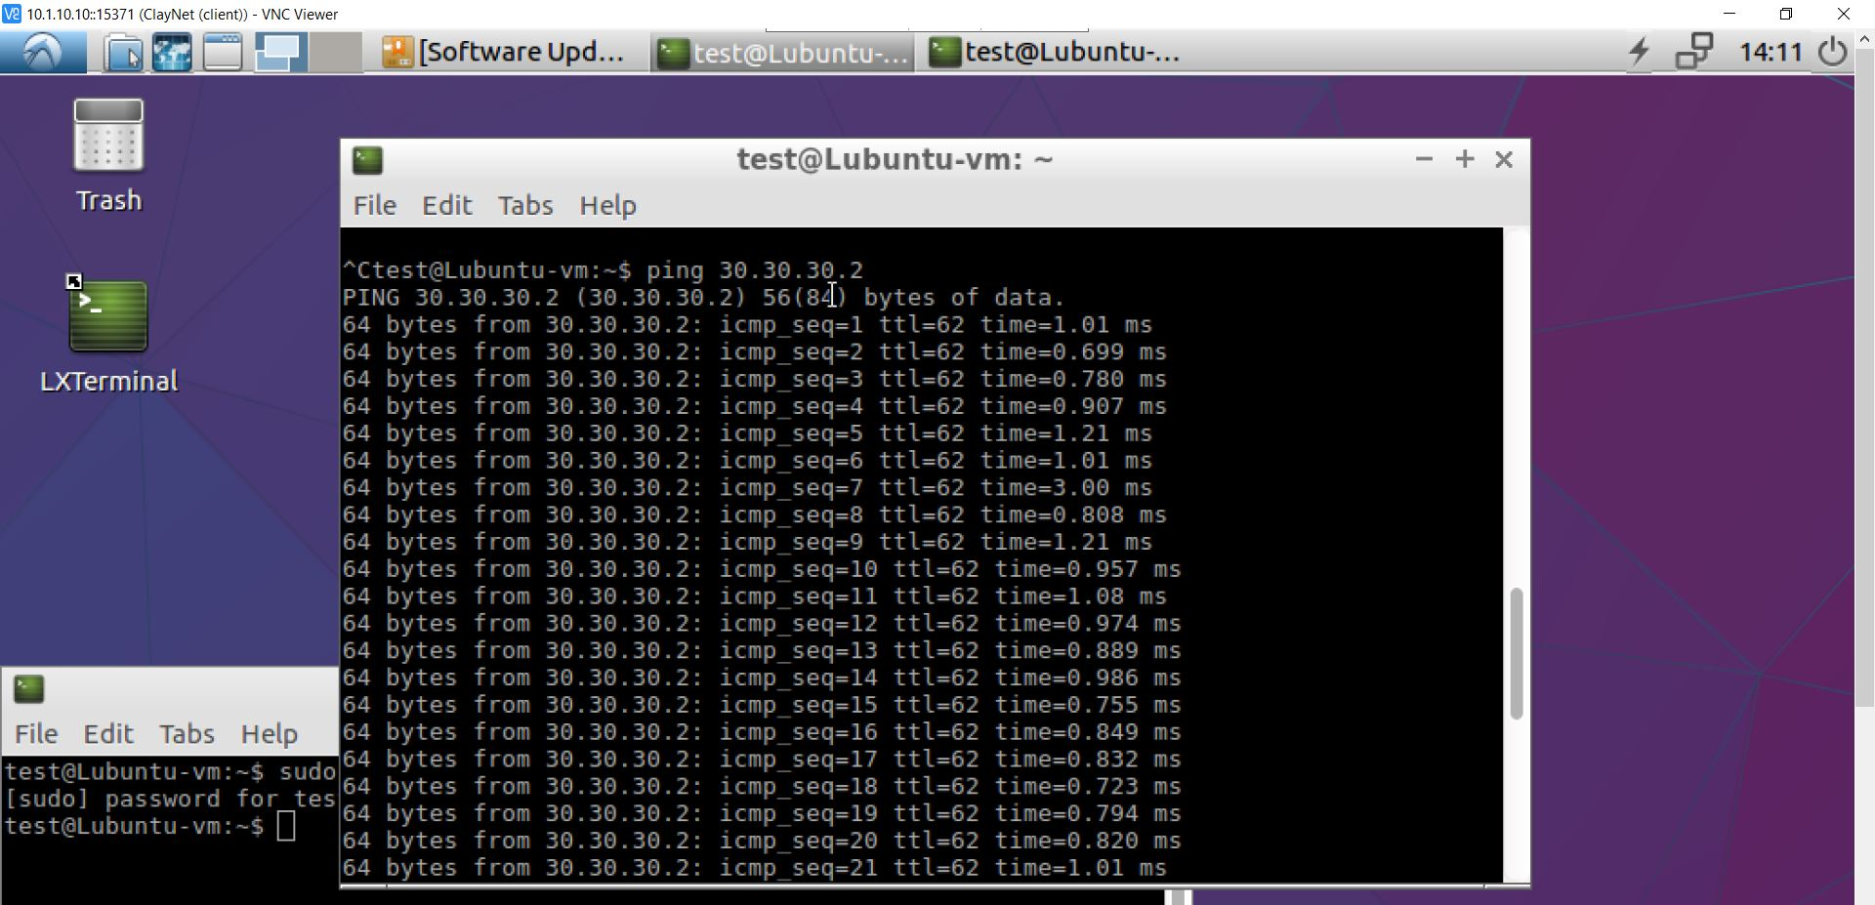

* The following Wireshark Packet Capture shows ICMP request packets being sent from Desktop1 to Server1.

